Project 5 Documentation

**Basic Overview**  
Scene 1 -   
An admittedly plain main menu screen, consisting of button and text GUI elements. The button, when pressed, takes you into Scene 2 and starts playing the game’s music (made myself, via BeepBox).  
  
Scene 2 –

A top-down 2.5D perspective of a wooden box arena, containing two tanks. One controlled by the player using WASD + Space controls to move and shoot, respectively. The other tank controlled by a basic Random Number Generator ‘AI’, that performs a random movement action then shoots. When the player or enemy move or shoot, the action will play a related sound effect (both found on random sfx websites, I didn’t note which). When a tank’s bullet collides with the other tank, that tank is destroyed and you are sent back to the main menu (currently not functional).

**Code Overview**

Scene 1 -

Being the more simplistic of the two, scene one contains minimal code to function, simply containing the code for a camera, the ‘music’ const, the game title, and the ‘start game’ button.  
  
Scene 2 -   
The more complicated of the two scenes, contains the code for a number of meshes to be made, sized, and parented as need, as well as the code for player functionality and the basic enemy ‘AI’ systems.

Player Movement functions off of a series of actionManagers, providing a variable that tells us the key being pressed.

The collision system withing the game, while not functional, works using an invisible mesh which functions as a hitbox for the tanks. When this hitbox is intersected/overlapped by the opposing tanks bullets, the tank should be destroyed.

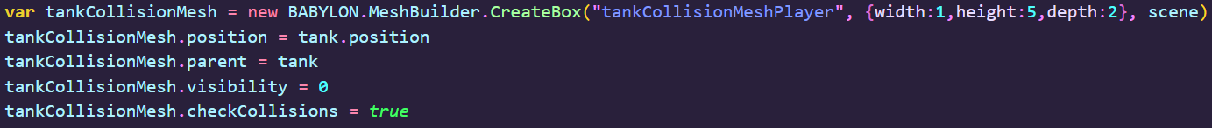

The scene also contains a shadow caster, and related lights, to provide a less-flat look to the game as you play.

The AI tank’s ability to shoot is run through an asynchronous function which it’s other actions call on as they end.

The AI tank’s functionality is run through a random number generator, where each outputted number results in an action, which is updated at the end of every bullet shot.



